!White paper

HEX: The First High Interest Blockchain Certificate of Deposit.

www.HEX.win

Summary

HEX is designed to increase in value faster than anything else in history. Bitcoin went up 26x from $750 to $20,000 in only 378 days. Ethereum went up 233x from $6 to $1,400 in 403 days. If you got in at $1 you made 7 times more. Imagine how 1,400x returns feel. Some people got in 3 times cheaper than that! Had you put in $223 when you first could, it would have gone up 4,500x to $1 Million, in only 3.5 years. Life changing. Most of me the wealth in world is made by those that get in first.

HEX is the first High Interest Blockchain CD. CDs, known as Certificates of Deposit or Time Deposits, are worth Trillions of dollars. CDs are worth more than gold, credit card companies, and cash. CDs pay higher interest than savings accounts, requiring money be deposited for a fixed time. Banks profit on poor customer service, early withdrawal fees, and auto-renewing you at worse rates. The % they pay you in interest doesn't keep up with the % prices increase. New USD is printed all the time, making yours less valuable. HEX replaces inefficient currencies, banks and payment networks with verifiably secure peer-to-peer technology. HEX takes the profit out of banks and government money printing and gives it to HEX holders.

Hex is designed to go higher, faster, and retain its value. How? Use a computer science breakthrough to disrupt the largest markets in the world with a product of nearly infinite profit margin. Eliminate middlemen, users can transform Ethereum directly into HEX. Kick-start adoption, give Bitcoiners free HEX. Help small guys, penalize Bitcoin whales. Early claimers get bonuses, late claimers get penalties. Pay bonuses to referrers and those referred. Pay the unclaimed coins and interest to those who time lock their HEX. Longer and larger stakes get more shares and the price per share only increases. HEX aligns incentives so the more people that participate the better everyone does!

HEX is future of finance, stake your claim! Buy Ethereum to transform it into HEX, claim for free if you have Bitcoin, or buy from someone who did! Stake HEX early, long and large, and watch it multiply!

HEX's Price Positive Game Theory (PPGT)

Every feature in HEX is designed to increase its price and adoption. It's a positive feedback loop. HEX rewards most those who acquire HEX the earliest, stake more for longer and refer others to do the same.

Name | Description
AdoptionAmplifier | Send ETH to the lobby. Your % of that day's total ETH gets the same % of that days HEX.
 | Day 1 mints Billion HEX. Days 2-351 have ~500 million, to as low as ~300 million if 100%
 | of FreeClaims are made.
Referral | Referred users get a 10% bonus minted and their referrer gets a 20% bonus minted.
Staking Bonuses | Launch phase only. Paid on day 353.
We'reAllSatoshi | Stakers get all the unclaimed HEX.
LateClaims | Every week a BTC holder doesn’t claim they lose 2% of it to stakers.

!Richard Page 1

 | SillyWhalePenalty | 1k-10k+ BTC claim penalties of 50%-75% their HEX goes to stakers. Multisig can't claim.
 | GoxMeNot | The 137,891 Mt.Gox BTC can't claim.
 | Staking Bonuses | Launch phase only. Paid daily.
 | CriticalMass | Amplifies staker pay up to 100% if 100% of possible BTC coins FreeClaim. Excludes
 |  | TruthEngine.
 | Virality | Amplifies staker pay up to 100% if 100% of possible BTC addresses FreeClaim. Excludes
 |  | TruthEngine.
 | Staking Benefits | Continuous (Permanent)
 | StakeSharePrice | Only increases. Set by the maximum ROI any stake ever ended at.
 | Staking | If 1% of HEX supply stakes, they average 369% interest e.g. If 2% then 184.5%, if 10%
 |  | then 36.9% Fewer stakers means higher interest. More stakers means less circulating
 |  | supply. 1 day minimum.
 | TrustlessInterest | HEX mints up to 3.69% of total supply a year to stakers. If only 1% of HEX is staked, avg
 |  | ROI is 369%
 | LongerPaysBetter | The longer you stake, the more you make. Up to 3x shares on a 3641 day stake.
 | BiggerPaysBetter | Up to 10% bonus shares at 150M HEX staked.
 | Compounding | Ending a stake to reinvest its yield never pays more HEX than having a longer stake.
 | TruthEngine | 50% of EmergencyEndStake penalties: 1/2 stake days, minimum 90. Can hit principal.
 |  | 50% of LateEndStake penalties: 1% of stake per week after 14 day grace period. Can hit
 |  | principal.
 | Claim Bonuses | Launch phase (353 days)
 | FreeClaim | 10k HEX per BTC (you don't need a whole BTC to claim.) When we say claim, we mean
 |  | this.
 | Speed | 20% day 1, reduces to 0% over 350 days.
 | AutoStake | FreeClaims start 90% staked for 350 days & can't EmergencyEndStake for them. Upgrade
 |  | to a longer stake and receive up to 3x shares.
 | Referral | Referred users get a 10% bonus minted and their referrer gets a 20% bonus minted.
• On website now

Never Before Seen Features!

HEX is the first blockchain certificate of deposit. Trustless interest. Pays holders instead of miners.

Staking HEX is like getting free mining hardware and electricity. Bitcoin miners get paid to dump the price. HEX stakers get paid to hold the price up.

No Satoshi (if he doesn't claim in 50 weeks) or Mt.Gox dumping on you. No inflation bug possible like bitcoin has had. Unit bias fixed. More distributed mining ecosystem. Whale penalty which gives whales coins to stakers, etc. Given programmable money the first program should be interest.

Around 12 million or more of the 18 million total BTC worth of HEX claims will be given to the stakers on day 353 by shares. And! It gets multiplied by the Viral and CriticalMass adoption bonus multipliers which can increase it up to 3x. The share price only goes up.

Stakers that end stake early or late pay loyal stakers. Longer stake commit pays 20% more per year, up to 3x shares, (partial years are fine). Lower fees, lower inflation. Referral program. Founder is a marketing expert with an audience. Early adopters get paid extremely well.

20% Speed bonus falling to 0% over the fifty weeks. Unclaimed coins paid to stakers 2% per week for 50 weeks. Every week you don’t claim, someone else gets your coins. Critical mass and Virality bonuses increase payouts to early stakers to cancel out desire to keep it a secret and get more unclaimed coins.

!Richard Page 2

Every pumpamental to lock up supply and increase price.

Hex has a lower inflation rate than Bitcoin, even after the rate was cut in half twice over 10 years. The inflation is also delayed, because it's only paid on ended stakes, and stakes can last 10 years. No trading of staked coins increases the value of unstaked coins, and chance people early endstake and pay penalties to loyal stakers.

Trustless Interest.

Let's say you want to make more bitcoin on your bitcoin, what are your options? You could lend your coins out and take the risk they're not returned, or you could try selling your coins for mining hardware and hope to get more coins back later. Lots of people have lost money trying either.

Counterparty risk in Bitcoin investments.

To earn interest on their Bitcoin, most users send them to a centralized third party, such as an exchange. There, coins can be borrowed to "short" the market. Sellers borrow the coins to sell, in the hopes that they can rebuy them cheaper before they have to return them, thus profiting from price decreases. These centralized parties are security holes that are often hacked, destroy privacy, or introduce fees if you want to get your funds out. Often coins you send to an exchange or lender are stolen. Not your keys, not your coins.

These centralized third parties and middlemen are so important to users seeking yield (making interest) that the companies themselves have made more profit on Bitcoin than its founder. Billions and billions of dollars of value has shifted into the pockets of middlemen. HEX fixes this.

This replaces these third parties with a trustless Peer-to-Peer to system. Instead of sending your HEX to an exchange so they can lend it out on your behalf to earn interest for you, you just lock it in same Smart Contract that minted all the HEX in the first place, and it credits you interest. If you're given programmable money, the first thing you should program is interest.

HEX pays interest to stakers instead of miners.

Some users try mining to make more cryptocurrency. Instead of sending your money to a foreign mega-corp to buy mining equipment which shows up late, used, or never at all, you can skip the depreciating asset and electricity bills and just stake your coins.

  - HEX is the first cryptocurrency with a chart of future sellable supply (expiring stakes over time.) This secures buyers confidence in future value of their investment.

HEX has Speculative Stickiness
Normal crypto currencies have: Price, hash rate.

HEX has: HEX price, Share price, Directly affects staker profit per share: % of supply staking , Average stake length, Average stake size, stake expiration chart over time, early & late end stake penalties.

- How can HEX make you rich?

Example: The HEX/USD price could go up 1,000x. You HEX stake return 10x your HEX. 1,000x times 10x = 10,000x profit.

Understanding the AA lobby.

Imagine a bucket with 1Billion HEX in it. (that's what day 1 looks like.) Now imagine an empty bucket users throw ETH into. End of day your % of ETH bucket gets that % of HEX bucket. Every day the buckets empty and start over for 351 days.
- Making the most HEX.

  - Send your ETH to the AA lobby.

  - If you held Bitcoin at the snapshot, FreeClaim with it. Then sell the BTC for ETH send it to the AA lobby.

  - Opt for 10 years on your 90% AutoStake and the HEX in your wallet, getting 3x shares at the lowest price per share possible.

  - When the AA lobby you joined closes at the end of the day, exit the lobby with your HEX and stake

!Richard Page 3

it for 10 years.
- When the BigPayDay hits on day 353, you'll get the largest share of it you could by staking early,
long and large.
Ways to maximize profit?
Get a great bargain on HEX early on from the Adoption Amplifier (AA) or FreeClaim.
Get the most shares for the HEX you stake by being early. The StakeSharePrice only goes up.
Stake longer. Increases shares up to 3x.
Stake bigger. Increases shares up to 1.1x.

Refer people (earning 20% on top of each person's HEX they receive from AA of FreeClaim.) Get people to FreeClaim, driving up adoption and the Virality and CriticalMass bonusses. Get people to stake, removing HEX from circulation. Get people to buy HEX.

Advanced Explanations link
- audits
- Talk in malta
- Linked in profiles

  - https://www.linkedin.com/in/dan-emmons https://www.linkedin.com/in/kyle-bahr-61ba73 https://www.linkedin.com/in/paulhughes42 https://www.linkedin.com/in/cody-lamson-web-dev/
- Tend to spread end stakes out when you see others exit times
- Advanced Explanations(production)
AdoptionAmplifier
- Get HEX directly during the 351 days. No middlemen with their fees and friction.

- If you don't already hold BTC, it's better to use AA instead of FreeClaim. You'll get more HEX that way. If you already hold BTC, you should use both. You can hold BTC for the snapshot. Then sell it for ETH and join the AA lobby day 1 and FreeClaim day 2.

- The AdoptionAmplifier(AA) mints HEX for people that want to transform ETH into HEX. Send your ETH to the lobby. Daily, your % of the ETH sent to the lobby transforms into the same % of the HEX available that day. Day 1 mints 1 Billion HEX. Days 2-351 mint ~500 million, decreasing as low as ~300 million if all FreeClaims possible are made. Day 351 is the last day AA runs, giving everyone time to get staked for the giant lump sum payout to stakers on day 353. Users Referred to AA get a 10% bonus minted and their referrer gets a 20% bonus minted. HEX from AA aren't AutoStaked like FreeClaimed HEX are. There is no 350 day minimum stake length on HEX from AA. HEX from AA can EmergencyEndStake whenever they like. FreeClaimed HEX can't EmergencyEndStake before their stake is 350 days old.

- It could be wise to put some ETH in AA every day. You might get lucky and have few other people join

that day, giving you a great bargain.
Why is AA so important?
- To onboard the 99% of the world that didn't have BTC at the snapshot.

Referrers can't get people to time travel back to before snapshot to buy BTC to FreeClaim with. They can onboard users to AA.

- Onboarding more users globally with no middlemen is massively important. Probably 10x adoption. More on ramps = more adoption.
- People do not want free things for free. People want expensive things for free. People need to be

Invested emotionally. That means sacrifice something of value, or watch the nest egg for a year grow. Which is the cheaper way to get HEX day 1? AA vs FreeClaim

- Since referrer/referee bonuses apply the same to AA and FreeClaims, they cancel out when comparing the two. SpeedBonus only affects FreeClaims.

- Math

  - Thus day 1 FreeClaim of 1 BTC= 12,000 HEX (10k base +20% SpeedBonus)

  - Day 1 AA = 1B HEX

  - 1B HEX / X = 12,000 HEX

  - X = 1B HEX / 12,000 HEX = 83,333

  - Which means day 1 AA has 83,333 worth of FreeClaimed BTC in it.

- Now, you must answer for yourself, what does it cost you to buy a bitcoin, and sell it back? And the risk of the price moving against you? Write a RoundTripCost in $ per a BTC.
- RoundTripCost * 83,333 = Total $ of ETH, if sent to AA, makes FreeClaiming cheaper than AA day 1.
- Now Guess how many $ of ETH you think will join AA day, and you'll know which way is cheaper.

!Richard Page 4

- Now, there's other days than just the first day. And you can get in at the last minute to get a better idea
what ratio you'll transform at.
Launch timing
- Days 2-351 mint less, equal to 1/350th the unclaimed HEX.

- AA has to be seeded because WAAS (unclaimed coins) don't exist day 1. Appears after first day of claims leave unclaimed coins.

- AA has to start a day early because it transforms ETH to HEX at the end of day. This synchronizes Claim & AA Stake Start times.

- The first thing to launch is the Adoption Amplifier (because it settles at end of day) and that synchronizes amplifiers with free claimers, so they can both start their stakes at the same time. Getting in the first AA period can be done over the day.

- Now, on day 2, when free claimers and AA guys are both getting their HEX and staking it, they're all staking it at the same price, because the price doesn't ratchet until someone ends stake.

- As long as you get in the first day, you will be on the same footing as everyone else that did.

Larger pie beats larger slice of smaller pie
- More users means makes HEX more valuable.

- The metric that matters most is onboarding new users. A larger pie outperforms a larger slice of a smaller pie. You can 1000x adoption. You can't 1000x your pie (if you own 1/10 of 1 % already)
- Not used
  - AA (needs picked for parts to pull up top)
    - Recycle ETH

      - ?It's better to have ETH to sell on exchange than need to sell HEX.

      - Dupe: People do not want free things for free. People want expensive things for free. People need to be Invested emotionally.

      - That means sacrifice something of value, or watch the nest egg for a year grow. Which is why top airdrop only coin is like number 27 market cap or lower.

      - EOS did a similar launch, got $4.2B of ETH and did a 40x in the middle of the bear market.

      - EOS made more money than Satoshi and Vitalik and Bitmex and Coinbase combined.

      - No one can stop anyone from pumping the price of basically any freely purchasable thing.

      - Would you prefer they sell ETH or HEX?

      - If you lock the ETH, they can just get a loan on it.

      - Everything on the blockchain is public, particularly recycling ETH, would be visible publicly.

      - Would be equivalent to raising the price, which most products and services don't tend to 10x their price as it might hurt sales. Raising prices is not without risk, or you would have $10,000 coca cola.

      - Would be detectable by lagging exchange price. People would just buy on exchanges instead.

      - What if they buy up the exchanges and AA? You're worried someone making the price of what you bought go up?

      - Intermittent reward is great

    - Cut

      - AA hate

Giving people free stuff is only as useful as they buy more or cause others to.
- Getting rid of dumpers

  - If you can about price, staking behavior shits on "decentralization"

- If you care about censorship resistance, ETH has better and more diverse miners than BTC already, and wants to do change their proof of work algorithm to eliminate any ASICs.

Price anchor

?This has the added benefit of a visible ETH/HEX ratio daily, where the supply of HEX available gets lower and lower, if static or increasing demand. ?An increasing ratio may act as a mental anchor for traders and exchanges.

- Cut
  - Which is why top airdrop only coin is like number 27 market cap or lower.

You can earn it through your own referral link for free. You can get it for free with even 0.0000001 BTC. You can transform as little as 0.0000000000000001 ETH for HEX.

Most of the money in crypto is made by those that buy in first

    - Bitcoin is 10 years old already. By the time you heayetr about a coin, it's already up 10x-1000x for those fi rst in. It's easier to 100x from $1 than from $10,000.

!Richard Page 5

- Dense summary
<section class="main-section">
<!--main-section alabaster-start-->
<div class="container">
<section class="business-talking">
<div class="container">
<h2>Dense Summary</h2>
</div>
</section>
<br>

HEX is the First Blockchain CD. Free Claimable with BTC sig, or turn ETH into HEX direct. Bonuses HEX: Early (20%), Referrer(20%), or Referred(10%); Staking: longer (300%), larger (10%). For first 50 weeks: Free HEX if BTC held at snapshot; Value of unmade claims decay 2% per week, paid to stakers. Unclaimed coins paid to stakers week 50; As % of coins and

- of addresses claimed increase, so does staker pay, by those same %; Copy of unclaimed HEX available daily: Send ETH to lobby, Your % of that days ETH gets that % of that days HEX. Origin gets copy of bonuses. Base claims, interest, and adoption amplifier aren't bonuses therefore it gets no copy from them. Free claims are AutoStaked 90% min 50 weeks.

</div>
</section>
  - Cut from trustless interest

    - As long as users desire to earn interest on their savings, trustless solutions should be made available to eliminate the fees and security holes middlemen introduce.

    - Trustless Interest means you are actually paying yourself when you end your stake.

    - Founders of exchanges that allow users to trade crypto currencies, borrow and lend them, have all made more money on cryptocurrency than the founder of Bitcoin himself.

- Staking
Around 12 million or more of the 18 million total BTC worth of HEX claims will be given to the stakers on day

- AND that gets multiplied by the Viral and CriticalMass adoption bonus multipliers! Stakers get paid by shares, and the share price only goes up, so staking earlier, longer and larger is better.

•

- HEX can be staked (time locked), paying higher interest to longer and larger stakes. Staked coins can't be moved to exchange to sell. The more people that stake, the lower the HEX supply, pushing USD value up. HEX mints up to 3.69% new coins a year to reward only stakers. The fewer people that stake, the more each stake makes. If only 10% of HEX is staked the average return per staker would be ~36.9% in HEX, plus profit from penalties on any stakes ended early or late, plus USD appreciation.

- Staking doesn't require you to own a computer or stay connected to the net. You only need to start and end your stakes.

- StakeSharePrice only increases. Those that get in earliest get the most shares for their staked HEX.
- Stakers get paid tons on all the coins that can't be claimed, won't be claimed or are claimed late.

  - Addresses ≥1000 BTC hold over 40% of all Bitcoin. The SillyWhalePenalty penalizes them up to 75%, paying stakers and giving the little guys a chance.

  - Multisig can't claim (most exchanges), pays stakers (stats: https://p2sh.info/dashboard/db/p2sh-repartition-by-type?orgId=1)
  - Only 350 days to claim. Pays stakers.
  - LateClaims nukes them the whole way 2% a week, pays stakers
  - 140k GOX and 96k PlusToken BTC can't claim.
  - Lost coins can't claim (est. 4M coins)
  - If Satoshi is dead, he probably won't claim (1M coins)
  - Add all that up and you'll find stakers are going to make a killing.

!Richard Page 6

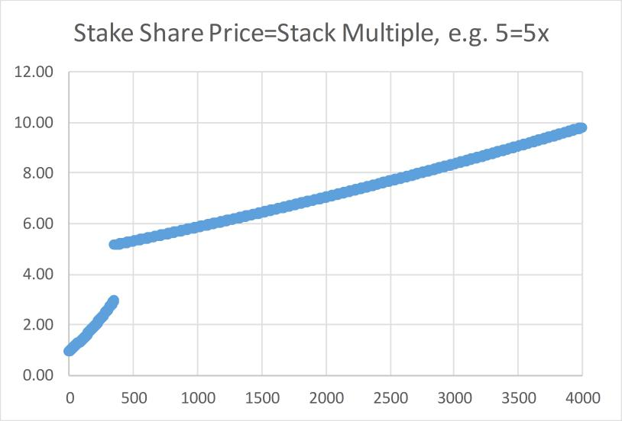

○

- LateClaims
- Multisig

- GOX WhalePenalties

- We'reAllSatoshi(WAAS) pays the unclaimed coins to stakers on day 353.

- The more people that claim (Virality), and the larger they claim (CriticalMass), the higher the payouts to stakers.

- The majority of profit for stakers comes on day 353 when they're paid WAAS plus CriticalMass and Virality bonuses on it.

- StakeSharePrice

HEX mints up to 3.69% a year to reward stakers. If you were the only staker, you could get 3.69% of all the entire currency all to yourself. You can always dream. When HEX starts, a single staked HEX gives you 1 share. If you stake longer or larger, you get bonus shares. As soon as any staker ends stake at a profit, the price of a share moves up. Instead of 1 HEX per a share, perhaps it will be 1.05 HEX per share. The price of a share in HEX keeps going up and only up as stakers end at higher and higher profit %. This is how early stakers interest is compounded, by raising the price of late comers. This is what keeps longer stakes paying better than shorter stakes.

- Claiming

  - FreeClaim HEX by submitting a signature from a bitcoin balance at the snapshot block. Claiming is secure and anonymous.

  - Addresses ≥1000 BTC hold over 40% of all Bitcoin. The SillyWhalePenalty penalizes them up to 75%, paying stakers and giving the little guys a chance.

  - SPEED bonus pays people to claim faster while LateClaims penalizes slow claimers and pays it to stakers. This is the carrot and the stick.

  - AutoStake makes free claiming less attractive to people that only want to sell and forces them to enjoy gains over time, turning them into buyers. Believers in HEX are likely to stake longer than 50 weeks anyway. All claiming ends on day 351.

  - Referred users get a 10% bonus minted and their referrer gets a 20% bonus minted.
- Favorite phrases not used yet
  - Haterade
    - If you don't refer them, someone else will.
    - Speed Bonus: Get in early, make a lot
    - LateClaims: Every day you don't claim, you pay the stakers some of your stack till there's none left.

Pumpamentals (game theory) ○ Inflation

!Richard Page 7

Bitcoin pays inflation (new coins) to miners. The miners pay comes is a "pool" it doesn't go up or down as more miners join or leave the group competing to mine them. Here's how you get 100's of % interest from a currency that only has 3.69% inflation.
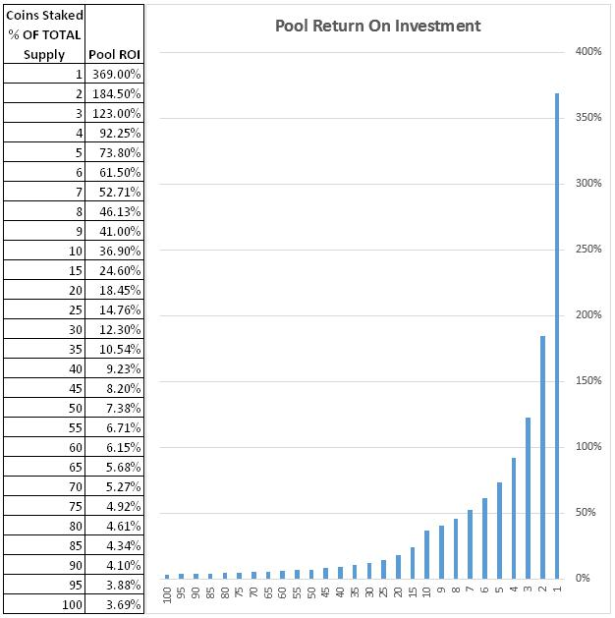

Thus, this chart is what #bitcoin miners profit would look like, if the miner mined all the new coins that year, but had to invest (%staked) amount of the currency to so. In this example you'd convert the Cost of owning a % of all coins into the same cost for mining hardware/electricity.

What this means is, If you were the only person getting all the bitcoin mining rewards, you'd get 4% of the whole currency a year. If you had to invest an amount equal to the whole market cap to do that, your ROI is just 4% however, if you could get those same rewards at less cost,

Then your profit percent (Return on investment) would just go higher and higher the lower your costs got (because you're already getting all the new coins). It's way easier to understand this in a staking model, like HEX, because you just time lock your coins, not buy mining hardware & electricity.

The point is, as long as the pool of people is small, the rewards are gigantic, even though the total inflation rate is quite low, in either mining or staking based rewards. Note there's more high at lower %

!Richard Page 8

in the chart. (changes shape.)

Bitcoin can inflate a little but pay massive ROI to people earning the new ones if not that many people are competing for them. (Just like HEX with staking)

HEX inflation vs Bitcoin
Bitcoin inflated 1000's of percent annualized in its first year. It took 10 years to get to 4.17%.

Due to the inflation paid as bonuses, it's not possible to know exact supply of HEX before the 50week launch phase is over. We do know, deterministically, what the future supply of HEX looks like after that. Here you can see it charted vs the same time in Bitcoins history.
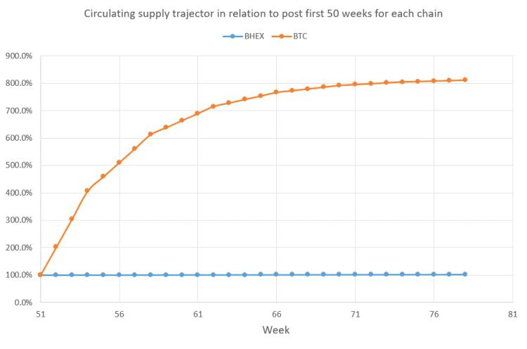

Bitcoin's inflation
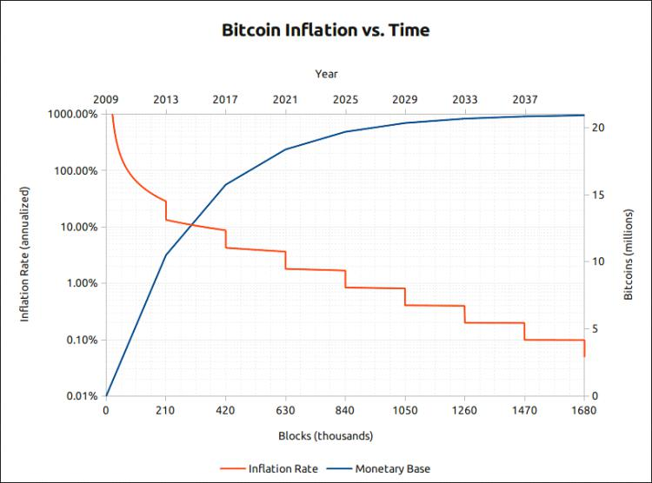

https://twitter.com/RichardHeartWin/status/1145683828134092801

From <https://twitter.com/>

Why is there no cap on supply? So unstaked people pay staked people via inflation. The average stake earns more than the inflation rate and always will.

!Richard Page 9

- Inflation in HEX is far better than inflation in fiat or mined coins

Inflation in mined coins and in fiat sucks more because it's usually given to people that aren't you. In HEX when you stake, you don't just become the bank, you become the Fed! The inflation doesn't get spent on electric bills, it just shifts value from non stakers to stakers.

On delay, because on paid to end stakes. And the people who are staked always earn more than the inflation. So unlike bitcoin which has externalities like electric bills. In HEX the money stay in the ecosystem.

Thus comparing inflation in mined coins with inflation with inflation in HEX is very misleading

In HEX it just goes non stakers value to stakers at a low rate over time.

A rate lower than bitcoins inflation had ever been last 10 years

People care about losing value to inflation. Hex inflation doesn't work like USD and other coin inflation

Usd inflation goes to people not you. In Hex if you stake you are the fed. Printing money for yourself.

For the record I just coined the phrase, in HEX, when you stake, you don't become the bank, you become the Fed!
- Inflation in Bitcoin

The #Bitcoin inflation rate is supposed to be 1 block reward of 12.5 #BTC per 10 minutes. There are 525,600 minutes in a year. So that's 52,560 blocks. 657,000 new $BTC in the next 12 months. There's 17,371,525 now. That's 3.78% We always overshoot because always more hash.

Who has the actual inflation rate based on that over shoot? I don't want to count blocks since 365 days ago and divide :) The overshoot is because the lag in the bi-weekly readjust difficulty function. I've manually verified that in the last 365 days 55,673 blocks were mined. Target was 52,560.

#Bitcoin network overshot by 3,113 blocks = 38,912 #BTC = .63% extra inflation. Therefore actual $BTC inflation= 695912.5/Supply at block 494092.

If supply was 16,676,488 at that block, then inflation for last 365 days was 4.1678%
- Being an affordable coin

- Remove freeloaders
  - WeAreAllSatoshi

  - GoxMeNot

    - By reducing the free coins claimable linearly over 50 weeks only those that got in the earliest, and thus participated the longest. Mt Gox trustee dumped on BitcoinCash holders because he got coins he didn't really deserve.

    - We don't want you at our party
      - Bad actors don't bring value, they subtract it

    - Multisig
  - SillyWhale
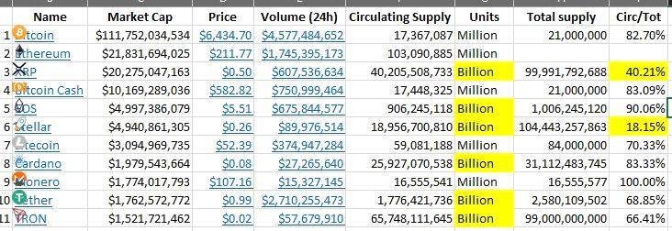

!Richard Page 10

    - Individual claims 1k to 10k+ btc penalized 50 to 75% linearly scaled before bonuses.
  - Limit orders

- Pay holders instead of Miners

      - More miners causes more selling of coins to pay electric bills, decreasing value.
      - More stakers takes more supply off market raising value.
      - Deferral of profits

        - Mining forces you to receive profits, an expired stake can have the "GoodAccounting" function run on it and defer delivery of profits until the staker wants to run the "EndStake" function.

      - Delayed inflation hitting market because lump on end stake
  - Staking - Trustless Interest
    - Proof of HODL

    - Virtual mining

      - Staking HEX is like getting mining hardware for free.

    - LoyalStaker rewards

      - EarlyEndStake

      - LateEndStake
    - Scarcity Engine

      - Value Ratchet

        - The best guess as to the future state of the staking pool is the current state of the staking pool. Early on this leads to large percentage returns on investment, as the pool starts at 0 and can go only up. As users see the potential for huge returns, they join the pool, reducing all other pool members payouts. By staking longer they further reduce other pool members payouts and increase their own.

      - Truth engine

        - This leads to more users joining the pool. Once you're in the pool you're incentivized to stay by an early withdrawal penalty equal to 1/2 the periods you committed to. Stakers will tend to be truthful in their commitments as to how long they will stake.

        - Loyal Stakers are paid 1/2 the EmergencyEndStake penalty that stakers who have ended their stake early

      - LongerPaysBetter
      - Distributed borrowing
        - Value is virtually loaned to non stakers.

        - The money is virtually lent via distributed lending to all unstaked coins, as they appreciate in value by the reduction in circulating supply via staked coins.

      - Auto-balancing

        - If more people stake you get less interest individually but the coins are rarer because they locked up
      - Compounding
  - GoxMeNot
  - Competition breeds success
  - Allow BTC value to be spoken on ETH network

- Why HEX is great
- Brand
Name

3 letters, rhymes with SEX, don't have to spell it out for anyone. The hexagon is a staple of futuristic design, HEX addresses are hexadecimal.

Logo

How can one embody exponential growth up and to the right? A hexagon growing up and to the right, larger over time. Logos must look good at very small sizes, for fine details are lost. What is the minimum detail that could show this growth? A line or two inside. The color transitions from yellow to magenta at a 60 degree angle transitioning through orange and red.
- Names

  - HEX Ticker symbol

Ticker symbols are not unique to assets across currencies, only unique in a single exchange.

!Richard Page 11

For instance BCH was called BCC on some exchanges, which was also the ticker for Bitconnect, I think, or some other currency. So BCH then became BAB or some such thing after the SV fork. Because HEX is not a ticker actually in use anywhere, we should be able to secure it everywhere. The "ticker symbol" field in ERC20 standard is also non-unique. Only the contract address is unique.

Choosing certificate of deposit over time deposit in marketing
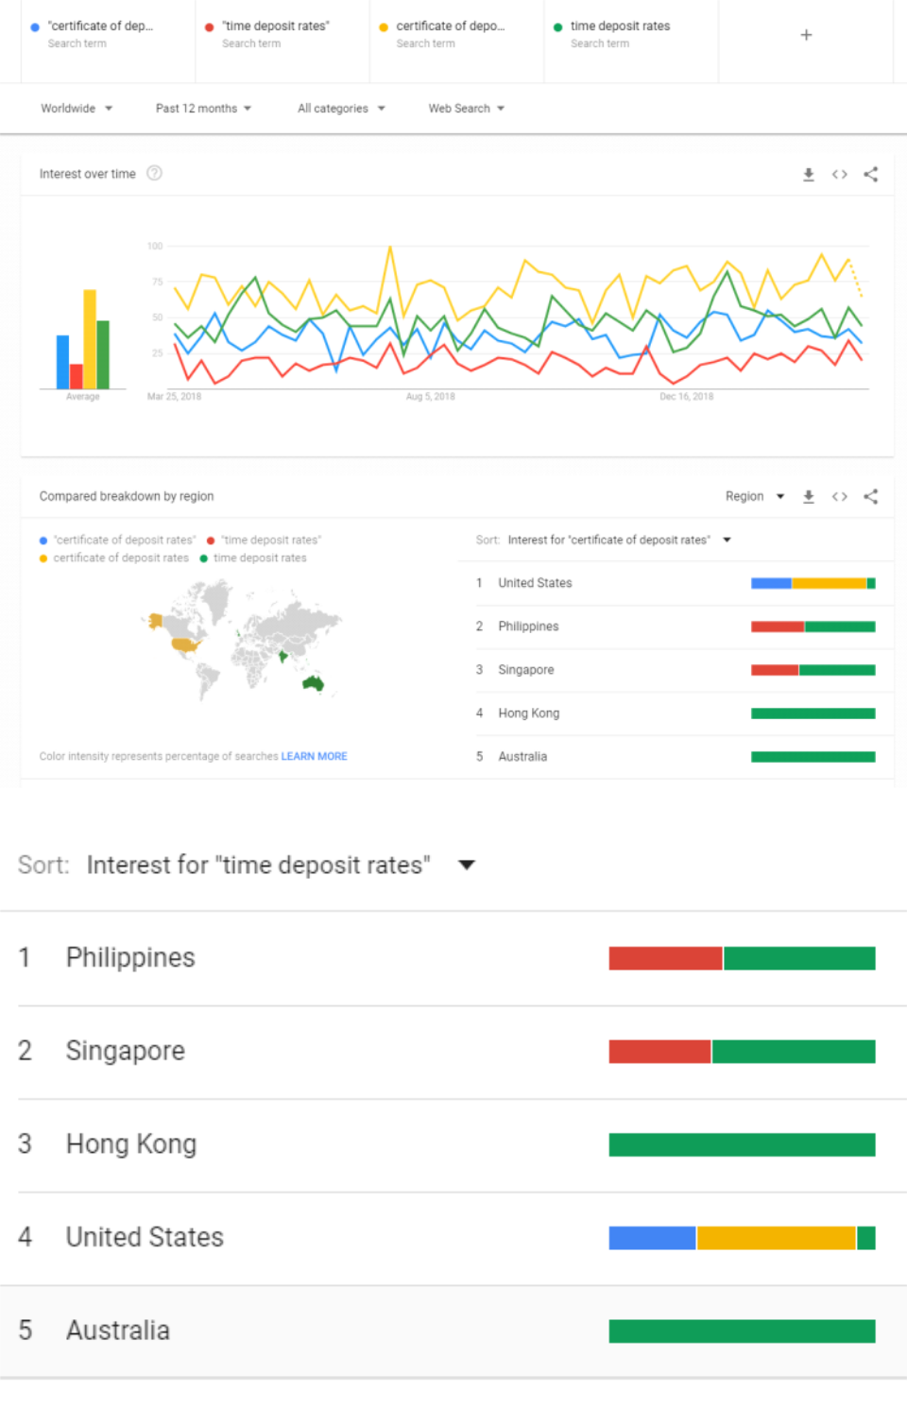

  - Promotes free speech. You can transmit your commercial and economic energy that used to only exist in the Bitcoin language, in the Ethereum language. Widens your range of people you can trade with, speak tokens to.

- Economics
  - Supply breakdown?

Maximums possible and minimums possible can be calculated. It's very hard. You could take the easy road and use stakehex.com and try different globals in the bottom right corner. My models show total

!Richard Page 12

supplies at end of launch phase (day 353) (only up to 3.69% coins can be minted per year after that day.)
Using 50% referred and claims even spread across all days, viral% same as crit %, 18M BTC total supply:

1.1M BTC claim= 640B
2.3M claim=667B
3.4M=692B
4.6M=714B
5.7M=733B
6.8M=750B
8M=763B
9.1M=774B
10.3M=781B
11.4M=7856B

It is unlikely that over 11.4M BTC can claim, as Multisig can't claim, 40% of all BTC are hit by 50-75% silly whale penalty, 200k coins from gox and plus token can't claim. You can get exact numbers from here:

•

- If you're trying to figure out how much AA will have vs Stakers vs FreeClaimers, the FreeClaimers are going to get their asses kicked, because they're too lazy to claim first day, if at all, and there's so many BTC, and all the whale penalties, and multisig can't claim, etc etc, so their loss is AA and Stakers gain, because both AA and Stakers get paid based off what those guys didn't claim.

FAQ
Update!

These need updated to include AdoptionAmplifier (AA), 10% be referred bonus, AutoStake, StakeSharePrice (only goes up,) BiggerPaysBetter (up to 10% bonus shares.); Massive payout on day 353 of We'reAllSatoshi (unclaimed coins), MultiSig can't claim, SillyWhalePenalties, LateClaims, GoxMeNot and Viral and CriticalMass multipliers on them!

Expand all questions
Copy URL button to go directly to answer
Disclaimer

HEX is not an airdrop or a fork. You mint your own coins when you FreeClaim using BTC or transform ETH into HEX. A wonderful innovation! An airdrop requires someone else control the coins and give them to you. A fork requires that some code exist and be forked.

Bitcoin Miners run computations and mint their own BTC reward if their computation matches what the network consensus code requires.

HEX Stakers run computations and mint their own HEX reward if their computation matches what the network consensus code requires.

In either network you can run your own code on your own machine, or pay someone else to run the code your choose for you to mint your reward. In Bitcoin the code lives in the node, in HEX the code lives in the node at a contract address. Paying a fee is paying someone to run your code.

The Howey test

(https://www.google.com/search?q=Howey+test) defines what U.S. federal securities laws apply to, which the SEC administers.

You must have no expectation of any benefit whatsoever from any ETH sent to the HEX contract or any HEX the origin address receives. You must have no expectation of profit from the efforts of others. You must have no reliance on the effort of others. HEX is just a piece of inert code at a contract address on the ETH network. It can do absolutely nothing on its own. Every HEX that ever exists is caused to exist by a user creating it himself per the rules of the code that he chooses to run that lives at an Ethereum contract address, and people might refer to as HEX, mining his own ETH block or paying an ETH miner to do it for him. Only you can mint your own HEX when you run the "leaveXfLobby" function's code, as it requires your private key. Only you can run the "startStake" function's code to stake your HEX, as it requires your private key. Staked HEX are actually "burnt" or "destroyed". Only you can mint your own HEX when you run the "endStake" function's code, as it requires

!Richard Page 13

your private key. The users themselves perform all the work. This is the same way that all BTC are caused to
exist, people run code and "coins" are created when the network's rules are met. Wherever possible you agree
there is no investment of money. Wherever possible you agree there is no common enterprise. Charitable
Donations may be sent directly to the contract by sending it ETH. If you want to join the AdoptionAmplifier
system, you must use joinXfLobby function.

Text to adopt in

The origin address does NOT get anything on users base claims or payouts on ended stakes. On bonuses, the origin address credited the same value or less that users do. Bonuses are: Speed, GoxMeNot, SillyWhalePenalty, LateClaims, Referrer, Referee, Virality, CriticalMass, We’reAllSatoshi, EmergencyEndStake Penalties, LateEndStake Penalties. The origin address receives nothing from AdoptionAmplifier lobbies, base claims, and payouts on ended stakes.

Wild IDEA Appeared!

I think I came up with a couple novel defenses for crypto projects being non securities. I'd love to share them with just the legal folks, so I guess I'll

- Paid really means credited
- Footnotes

  - [0] The lump sum payment on day 352 is larger than the AA due to higher critical mass and virality bonuses as adoption increases. 1 Billion HEX is seeded into AA because it settles at beginning of the next day and would allow first BTC free claimants and first AA users to start stake the same day.

  - [1] HD wallets, Multisig, CheckTimeLockVerify, Segwit, Confidential Transactions, Schnorr signatures, MimbleWimble, etc. Just make, send/receive/mine a little different. They do not change the Send/Receive/Mine paradigm. They're not going to bear interest. Segwit barely made it in. It wasn't as contentious as anonymity or economics changes would be. They're likely to find consensus. This is similar to how once IPv4 was in enough silicon, it just couldn't be changed anymore.

  - [2] https://fred.stlouisfed.org/series/STDSL, https://fred.stlouisfed.org/series/LTDACBM027NBOG, https://www.federalreserve.gov/releases/h6/20190321/

  - [3] https://www.ceicdata.com/en/china/money-supply/money-supply-m2-quasi-money-time-deposit
  - [4] https://www.federalreserve.gov/releases/z1/20190307/z1.pdf

  - [999]Circled the coins that gave away free tokens when they launched. 2 of which only given to #Bitcoin holders. All Bitcoin were literally free and given away by everyone to everyone for they didn't even have a price till May 22, 2010. Project launched Jan 3, 2009 (though the next block came 6 days later.) That's 1 year + of free.

On Production website
- Pasteable Summary (optimized)
  - Add copy button.

HEX is the First Blockchain CD. Free Claimable with BTC sig, or turn ETH into HEX direct. Bonuses HEX: Early (20%), Referrer(20%), or Referred(10%); Staking: Longer (300%), Larger (10%). For first 50 weeks: Free HEX if BTC held at snapshot; Value of unmade claims decay 2% per week, paid to stakers. Unclaimed coins paid to stakers week 50; As % of coins and % of addresses claimed increase, so does staker pay, by those same %; Copy of unclaimed HEX available daily: Send ETH to lobby, Your % of that days ETH gets that % of that days HEX. Free claims are AutoStaked 90% min 50 weeks.

- Home

  - Stakers earn 12 million or more BTC worth of HEX claims on day 353 by shares. Up to 3x if 100% claim. Share price only goes up. Transform ETH into HEX, claim if you have Bitcoin, or both! Multiply your stack!

- Status

HEX should launch in November 2019. We're 80% complete with dual independent security audits with two top firms (10/12/2019.) The code fixes have been submitted for final review. Once they are approved, the audits will be complete and we will release their reports. HEX might be the first coin to ever have two independent security audits. We've added links to the HEX advanced contract guide written by Kyle Bahr and the HEX profit simulator written by Paul Hughes.

Our Twitter and Telegram followers have been kept updated very often. Our website and email list followers have not. Please follow us! If you weren't following us, there's some important improvements that didn't get added to this website until September 2019.

- TechSpecs

!Richard Page 14

You don't need to understand most of the things on this page. If you love details and understanding things very deeply, this is the place for you.
- [mine the BTC and HEX comparison to anonymize the tech specs without BTC references]

- HEX is a hybrid proof of work(POW) and proof of stake(POS) system. Stakers are paid handsomely in HEX while miners can be paid pennies in ETH to perform your HEX transaction.

- HEX conforms to the ERC20 standard to maximize interoperability and security. Every HEX is made up for 100,000,000 Hearts (1 with 8 zeroes or 100 Million. Which is funny because when you stake, you get "staked hearts."

- Hardware wallet support: Trezor and Ledger are integrated with both MetaMask (for HEX and ETH) and Electrum (for Bitcoin)

- FreeClaiming is totally secure. Generating signatures is a standard feature in Bitcoin and can be done totally offline. <a href="https://Electrum.org">Electrum</a> is a great Bitcoin wallet. If you use a trezor or ledger hardware wallet, you use it through <a href="https://Electrum.org">Electrum</a> which is a handy way to generate your BTC FreeClaim signature if the software you're using doesn't have the feature. Your private keys stay safe inside your hardware device this way.
- HEX is easily extensible because smart contracts can built on top of it or reference it.
- HEX works with distributed exchanges and atomic swaps easily.

Bitcoin and HEX comparison.[Link]
- Code
  - Kyle Bahr wrote an Advanced analysis of how HEX works. [link]

  - HEX might be the only coin to undergo two independent security audits. They are both 80% complete. The code here is from 9-27-2019. This is not the final locked code, which will be available when the audits are published. This code does have fixes for issues discovered during audit. You can read these files in a text editor. HEX is written in the solidity language

- Timing Excel!
- Stakers get rich on day 353.
Around 12 million or more of the 18 million total BTC worth of HEX claims will be given to the
stakers on day 353. And! It gets multiplied by the Viral and CriticalMass adoption bonus
multipliers which can up to triple it! Stakers get paid by shares, and the share price only goes up,

so staking earlier, longer and larger is better.

As of 9/29/2019:

  - Only about 12.6M BTC of the 18M total bitcoin can claim because MultiSig can't claim (most exchanges), and GoxMeNot, etc.

  - What's left gets hammered with SillyWhalePenalties since 42% of Bitcoin is held in addresses of over 1,000BTC. See <a href="https://bitinfocharts.com/top-100-richest-bitcoin-addresses.html"> Bitcoin Rich List</a>.
  - 2.7M BTC in addresses over 10,000BTC pay their 75% penalty to stakers. That's 2M BTC worth.

  - Roughly 4.8M BTC is in the range of 1k-10k BTC addresses, and gets hit with 50%-75% penalties they pay to stakers, let's estimate it at 62.5%, so 3M BTC worth.

So we're already down to 7.6M BTC of claims effectively. But wait, there's more.
  - 4M BTC is thought to be lost, 1M BTC is thought to be Satoshi's (likely deceased.)

  - LateClaims hits for 2% of their possible claim every week they don’t claim.

The moral of the story is that stakers will multiply their HEX stacks on day 353 when all these bonuses get paid to them

Bitcoin has several different address types. The majority of bitcoin is held in addresses that can be used to FreeClaim HEX. Some Bitcoin address types cannot FreeClaim HEX. 66.3% of BTC is in addresses starting with 1. 8.69% are in addresses starting with 3 or BC1 of type: P2SH or BC1 wrapped P2WPKH. Most exchanges and whales/institutions use multisig, which is not supported.

HEX gives the common man a chance and pays the Stakers all the coins that can't or don't claim!
- BTC FreeClaim supported addresses

Address | Segwit? | Supported |  | Statistics
starts
with
1 | N | P2PKH. Holds 10 million BTC (56.5%) |  | https://p2sh.in
 |  |  |  | fo/dashboard/

!Richard Page 15

 |  |  |  |  | db/pay-to-
 |  |  |  |  | pubkey-hash-
 |  |  |  |  | statistics?
 |  |  |  |  | orgId=1
 | 1 | N | P2PK. Holds 1.76 million BTC (9.8%) |  | https://p2sh.in
 |  |  |  |  | fo/dashboard/
 |  |  |  |  | db/pubkey-
 |  |  |  |  | statistics?
• |  |  |  |  | orgId=1
 | BC1 | Y | Segwit: BC1: Native P2WPKH. Holds 334 thousand BTC |  | https://p2sh.in
 |  |  | (1.8%) |  | fo/dashboard/
 |  |  |  |  | db/p2wpkh-
 |  |  |  |  | statistics?
 |  |  |  |  | orgId=1
 | 3 | Y | Segwit: P2SH-wrapped P2WPKH . If you click the link to the |  | https://p2sh.in
 |  |  | right, this is teal on the chart, and some portion of the green |  | fo/dashboard/
 |  |  | (unspent.) You can't know what the script is until it's spent |  | db/p2sh-
 |  |  | from. Which would, on this chart, turn some of that green |  | repartition-by-
 |  |  | into other colors of known types. 3.6M BTC (20% of total |  | type?orgId=1
 |  |  | BTC) is of unspent / unknown P2SH type. You would have to
 |  |  | guess how much of that turns out to be the P2WPKH type of
 |  |  | P2SH which HEX supports. 872k BTC (5% of total BTC) is
 |  |  | known supported P2WPHK P2SH type.

- Nothing else is supported. For instance, multisig is not supported. Here's a guide to Bitcoin's very complicated address system: https://bitcoin.org/en/transactions-guide.

- Cut!
  - Pay formats
    - Addresses start with 1:

    - Pay-to-Pubkey-Hash or

    - Pay-to-Pubkey or

    - Bech32, Native Segwit, Pay-to-Witness-Pubkey-Hash or

    - in Pay-to-Script-Hash (P2SH)

    - Segwit

As of 9-29-2019 it means that 10M(P2PKH) + 1.76M(P2PK)+ 872k(P2WPKHinP2SH) + 334k(P2WPKH) = 12.97M BTC is known to be able to claim (before whale penalties, GoxmeNot, lateClaims.) Up to 100% of the unknown p2sh could claim which is 3.6M if it turns out the addresses were P2WPKH scripts. This is basically the same info that you see at the beginning of this section, with emphasis on the unknown p2sh scripts being able to claim. So it says about 12.6M up there, because it's not possible to know which p2sh addresses will end up being able to claim.

<b>Summary</b><p>

As of 9-29-2019 it means that 10M(P2PKH) + 1.76M(P2PK)+ 872k(P2WPKHinP2SH) + 3 34k(P2WPKH) = 12.97M BTC is known to be able to claim (before whale penalties, Gox meNot, lateClaims.) Up to 100% of the unknown p2sh could claim which is 3.6M if it tu rns out the addresses were P2WPKH scripts. This is basically the same info that you se e at the beginning of this section, with emphasis on the unknown p2sh scripts being a ble to claim. So it says about 12.6M up there because there's about 400k BTC in MtGO X and PlusToken Ponzi coins that GOXmeNOT would remove. It's not possible to know which p2sh addresses will end up being able to claim.</p> <br>

- OLD
Claims (THIS NEEDS FIXED FOR p2wpkh in p2sh)
17.4 M #Bitcoin exist.
Only 10.5 M are in normal P2PKH format
Only 1.76 M are in P2PK

!Richard Page 16

Only .14 are in Bech32 format (can claim)

.14 M are in GOX (which can't claim, because GoxMeNot) =12.26M claimable

And of that, the Silly Whale penalty is going to hit these guys for about 2.6M coins left over after 4.4M penalty.
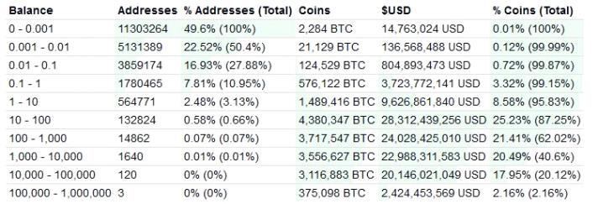

▪

The math used to estimate the silly whale penalty (the actual math scales from 1k to 10k+ up the penalty, where my estimate is a step function.)
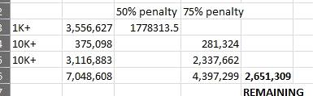

Sort

Did video card manufacturers make their own cryptocurrency and take away half of #Bitcoin's hash rate for a while? sha-256 ASIC manufacturers did. Do video card manufactures have covert ASIC boost? Are video cards distributed more widely? ASIC resistance is great. GPU mining also onboards hobbyists, ASIC mining doesnt.

- cut out code
  - home
<section class="business-talking">
<!--business-talking-start-->
<div class="container">

<h2>HEX is designed to increase in value faster than anything else in history</h2> </div>

</section>

<br>
- Energy consumption

  - HEX solves this. HEX vastly reduces pollution, paying miners only transaction fees and not inflation. Extra savings realized by utilizing an existing network, and employing time locks.

    - Cut: Since the energy used to mine a resource trends towards the value of the resource.

    - The resource in cryptocurrencies is the block reward + fees.
    - Hackernews

I developed something that can help reduce some of these problems. The energy used to mine a resource trends towards the value of the resource. The resource in cryptocurrencies is the block reward + fees.

One can reduces pollution by paying miners only transaction fees and not inflation. One further increase savings by utilizing an existing network, and employing time locks. More hashrate is not what matters most. Hashrate from honest, non cooperative parties is what makes the system censorship and collusion resistant. On GPU and CPU mined algos, hash rate matters more as a larger set of humans can become attackers.

- https://news.ycombinator.com/item?id=21276544

- https://qz.com/1204840/iceland-will-use-more-electricity-mining-bitcoins-than-powering-homes/

!Richard Page 17

- https://www.wired.com/story/bitcoins-climate-impact-global-cures-local/

- https://digiconomist.net/bitcoin-energy-consumption
- https://qz.com/1250980/an-australian-coal-power-plant-will-reopen-to-help-mine-bitcoins/
•

!Richard Page 18

